Subject: Year End Planning Tips
A few items you should consider in the last month of this year.
Payments due by December 31, 2024
- Charitable gifts
- Policial contributions
- Medical expenses
- Union and professional membership dues
- Contributions to your RRSP if you turned 71 during 2024 (you will also have to wind up your RRSP by this date).
Tax Free Savings Accounts
- You can contribute up to 7000 into a TFSA for the 2024 Calendar year as long as you are over 18 and a resident of Canada. If you have not made any TFSA contributions in previous years and are 32 or older in 2024, you may be able to contribute a total of $95,000.
  - If you need to withdraw from your TFSA, consider doing this by year end rather than waiting to 2025 because these withdrawals are not added to your TFSA contribution limit until the beginning of the year following the year you made the withdrawal. For example, if you withdraw $5,000 from your TFSA in December 2024, your TFSA contribution limit will be increased by $5,000 in 2025.
Saving for a First Home
- If you know of someone who is saving for a first home, they may want to consider opening a First Home Savings Account (FHSA) where a personal can deduct contributions up to $8,000 annually and lifetime maximum of $40,000. Contribution room does not increase until the FHSA account is opened, consider opening an account if you do not already have one and intend to save for your first home.
Do you have a trust?
- If you have a trust, you may need to provide additional information in a trust income tax return each year. New trust reporting requirements apply to tax years ending on or after December 31, 2023.
- If your trust is a bare trust (i.e. an example of a bare trust is a bank account between a child over the age of 18 and a parent), you do not need to file a trust income tax return for 2024 and only have to provide these details if the Canada Revenue Agency specifically requests them.
Registered Education Savings Plan
- For registered education savings plans, you can contribute up to $2,500 annually to receive a 20% government grant under the Canada Education Savings Grant program.

If you have any questions or concerns, please do not hesitate to contact me.
Seasons Greetings!
Don

______________________________________________________________________
Don McGugan, MBA, CFP
Portfolio Manager
Senior Wealth Advisor
Senior Investment Advisor
Financial Planner
BMO Nesbitt Burns
www.donmcgugan.com

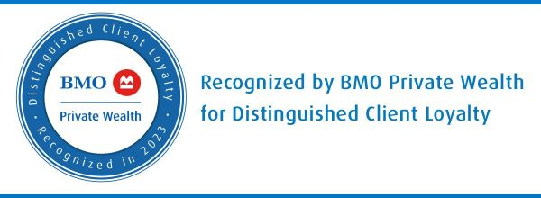

Investment Team
Prelipceanu, Helene
Investment Representative
Assistant to Don McGugan
BMO Nesbitt Burns
Phone (519) 258-2448

Office Locations
Chatham Office
819 St Clair Street
Chatham, Ontario N7M 5J7
Phone (519) 354-7060
Toll-free (866) 575-0255

Wallaceburg Office
770 James Street
Wallaceburg, Ontario N8A 2P5
Phone (519) 627-8782
Toll-free (800) 354-9127

Sarnia Office
429 Exmouth St, Suite 203,
Sarnia, Ontario N7T 5P1
Phone (519)344-8181
Toll-free (888) 229-9901

Mailing Address
100 Ouellette Avenue, Suite 1100
Windsor, Ontario
N9A 6T3

At BMO Nesbitt Burns, we care about the safety of our clients and professionals. To help keep you and our team healthy, and to support public health efforts to manage the spread of COVID-19, we are striving to eliminate traffic to our offices. We are still open for business, and happy to connect by email, phone or using one of our virtual meeting options. Thank you for your understanding. Your safety will always be our priority.

Please note: We cannot take trading instructions via email or voice mail, please contact your Investment Advisor directly.
For disclaimer details, please click here: http://www.bmo.com/nesbittburns/popups/about-us/disclaimers.

Veuillez prendre note que nous ne pouvons accepter des instructions de négociation par courriel, par téléphone ou par messagerie vocale. Veuillez communiquer directement avec votre conseiller en placement.
Pour plus de détails sur l’avis de non-responsabilité, cliquez ici : http://www.bmo.com/nesbittburns/popups/about-us/disclaimers.

