U.S. Trade deficits and U.S. fiscal deficits – a brief explanation on how this relationship works
As we have heard much about tariffs, trade balances, trade deficits (and I know we will hear more about this), I thought it wise to explain to you how changing one aspect of the U.S. Trade Decficit (partiluarlily with China) also impacts U.S. Fiscal Deficits.
First, some definitions;
- Trade Deficit – when a nation (i.e. United States) purchases more from a county (i.e. China), that nation has a trade deficit – the United States is buying more goods from China than what they are selling to China.
- Fiscal Deficit – when a nation spends more in a year than what it takes in from all revenue sources. The Congressional Budget Office which provides nonpartisan analysis for the U.S. Congress, estimates that the deficit for fiscal year 2025 will be 1.9 trillion dollars which is 6.2 percent of gross domestic product (GDP).
  - It should be pointed out that until 2010, it was very rare for the US to run a deficit that is larger than 5% of GDP. As the chart below shows, it was during World War 2, that the US ran massive deficits compared to GDP. However, since 2010, it has been more common to run deficits larger than 5% of GDP.
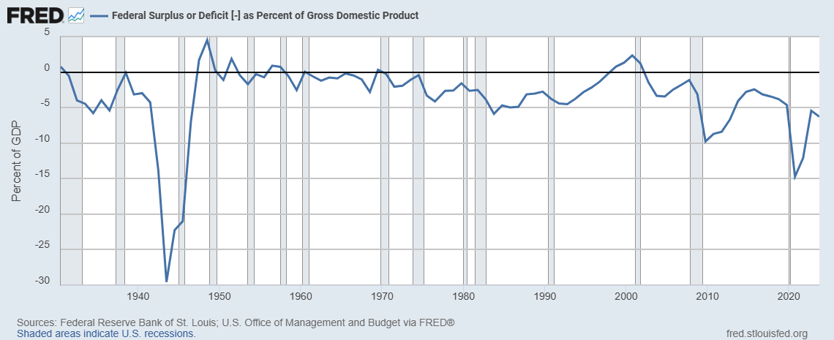

Second, lets follow the funds flow when goods are purchased by a U.S. importer and a Chinese exporter.

An importer in the U.S purchases a widget from an exporter in China and pays U.S dollars for the widget. The Chinese exporter sends the widget, receives U.S dollars and take it to a bank in China to convert to Chinese Renmindi (their currency). Given the substantial trade deficit the U.S has with China, over time, the Chinese banks/government would acquire a substantial amount of U.S dollars.

Then what does the Chinese government to do with US dollars? If they sell US dollars and convert to Remindi, they would reduce the value of the US dollar and increase the value of the renminbi. In order to keep export prices low, China must keep the renminbi low verses the U.S. dollar. So if large scale currency transactions would upset the exchange rate between the two countries, what else do you do with U.S dollars if you are the Chinese government?

With the US government running such large annual deficits, the US Treasury is being forced to issue more bonds and China is a substantial buyer of these bonds. So, in effect, the substantial trade deficit is actually helping the US finance their deficit.

Below is a graphical description of the relationship.

US dollars
US bonds
US Dollars
Chinese Bank/Gov’t
Chinese Renmindi
US Treasury
Goods from China to US
US Dollars to pay for goods
Chinese exporter
US Importer

Three, changing one aspect of the relationship impacts other areas of the relationship.
As we know, when there are substantial changes to a relationship, there are impacts – some can be good, some can be bad, sometimes they are unknown when the change is implemented. However, there are always changes when one party makes a substantial impact to a relationship.
If the United States wants to reduce the trade deficit with China in a substantial manner, they will need to find an alternative way of financing their fiscal deficits. There are several possible ways of doing this;
- Run small fiscal deficits. This would require lower spending or higher taxes/tariffs/revenue.
- Find alternatives buyers of US debit – US citizens can buy US debt and finance the deficit. However, the current personal savings rate for each US citizen is 3.90%. At this savings rate, the average American’s savings are 32% behind where they should be when scaled against their salary. However, saving more means foregoing purchases of goods and services which can impact economic growth. An additional way of attracting other investors to debt is to offer a higher interest rate on debt that is issued (thereby increasing the interest cost on US debt and interest payments).
- Manufacture more goods in the United States – this is a longer-term solution as manufacturing facility can not be created quickly nor can workers be found for these facilities quickly.
- Depreciate the US dollar – if the Chinese Renmindi increases in value relative to the US dollar, it makes goods imported from China more expensive and less attractive. However, this increase the cost of goods and can impact inflation
This is a brief list of actions that can be taken to reduce trade deficits/fiscal deficits. However, none are easy and all require some level of pain.
Four, conclusion.
Going back to where I started, whenever there is a substantial change to a relationship, there are impacts. Trying to solve something as substantial like a trade deficit or fiscal deficit, it takes planning, analysis and some level of pain or discomfort. These are not changes that are done quickly or easily.
I hope this gives you a top level explanation of how challenging it is to try and solve one aspect of a complicated relationship. Only trying to solve one aspect (i.e. reducing trade deficits) does have an impact on other parts of the relationship.
If you have any questions, please let me know.
Don
The opinions, estimates and projections contained herein are those of the author as of the date hereof and are subject to change without notice and may not reflect those of BMO Nesbitt Burns Inc. ("BMO NBI"). Every effort has been made to ensure that the contents have been compiled or derived from sources believed to be reliable and contain information and opinions that are accurate and complete. Information may be available to BMO NBI or its affiliates that is not reflected herein. However, neither the author nor BMO NBI makes any representation or warranty, express or implied, in respect thereof, takes any responsibility for any errors or omissions which may be contained herein or accepts any liability whatsoever for any loss arising from any use of or reliance on this report or its contents. This report is not to be construed as an offer to sell or a solicitation for or an offer to buy any securities. BMO NBI, its affiliates and/or their respective officers, directors or employees may from time to time acquire, hold or sell securities mentioned herein as principal or agent. BMO NBI -will buy from or sell to customers securities of issuers mentioned herein on a principal basis. BMO NBI, its affiliates, officers, directors or employees may have a long or short position in the securities discussed herein, related securities or in options, futures or other derivative instruments based thereon. BMO NBI or its affiliates may act as financial advisor and/or underwriter for the issuers mentioned herein and may receive remuneration for same. A significant lending relationship may exist between Bank of Montreal, or its affiliates, and certain of the issuers mentioned herein. BMO NBI is a wholly owned subsidiary of Bank of Montreal. Any U.S. person wishing to effect transactions in any security discussed herein should do so through BMO Nesbitt Burns Corp. Member-Canadian Investor Protection Fund.

Frequently Asked Questions (FAQs) | Congressional Budget Office
Personal Saving Rate (PSAVERT) | FRED | St. Louis Fed
Americans are saving less in 2023: 'I'm concerned,' top economist says

