Tariffs, Moving Manufacturing to America, Trade Balances
Lots of headlines on the above in the last few months. Let’s dive a little bit deeper and give some perspective.
First – tariffs.
What is a tariff? A tariff is a tax imposed by a country on imported goods. The tariff/tax is collected by a country’s customs authority or agency when goods cross the border. The typical purpose is to increase the attractiveness of domestically produced goods relative to imported goods.
There are many countries that impose tariffs and usually the countries with the highest tariffs are developing countries where they are trying to protect or develop domestic manufacturing. With the latest data we have (2022) the countries with the highest Weighted Mean Applied Tariffs are;
- Bermuda – 29.5%
- Solomon Island – 20.7%
- Cayman Islands – 20.41% (2021 data)
- Republic of Congo – 18.2%
- Equatorial Guinea – 18.2%
- Cameron – 18.1%
- Belize – 18.1%
- Djibouti – 17.6% (2014 data)
- Chad – 16.8%
- Gabon – 16.6%
Source: Which Countries Have the Highest Tariffs?
Overall, the average World tariff rate is 2.59% for goods.
Again, the objective of tariffs is to protect domestic manufacturing – increase the price of foreign goods and allow domestic manufacturing to have a captive domestic market.
Finally, who pays for the tariff. The tariff is based on the value of the goods shipped across the border. Sometimes an exporter may lower the price of the goods they are shipping so their product will not increase by the full amount of the tariff. For example, a “wigit” costs $100, there is a 25% tariff placed on that widget leading to the cost being increased to $125. The exporter may decrease the price of the widget from $100 to $90 and the final cost of the item is $112.50 ($90 times 25% plus $90 equals $112.50). This decrease does lower the profit margin for the exporter but the exporter (in this example) accepts this in an attempt to keep their goods competitive.
You may have heard from some politicians that the exporting nation plays the tariff. The tariff is paid by the final purchaser of the good (the consumer). The increased price reflected in the tariff is passed along as each intermediary who touches the good (purchases and resells it) until the final consumer purchases it. THE ONLY WAY A FOREIGN NATION IS PAYING THE TARIFF IS IF A FOREIGN GOVERNMENT SUBSIZIES THE TARIFF BY GIVING THE COMPANY THAT INCURS THE TARIFF FUNDS TO OFFSET THE TARIFF. For example, from my first example, if a widget costs $100 and there is a 25% tariff placed on that widget, the government where the manufacturer is located provides the company a direct payment which allows the company to lower the cost of their widget. I know of no nation who is currently doing this.
The last item to start about tariffs is that when they are placed on goods entering a nation, the domestic producers of that good also increases their prices of their goods. As an example, aluminum in the US Midwest rallied to a record high in mid-march after the 25% tariff on aluminum was introduced by the United States and the price is up almost 60% since the start of 2025. Even if the aluminum was produced in the United States, the aluminum price has increased.
As a final comment on tariffs, they are a tax and the make the cost of goods more expensive.
Movement of Manufacturing to America
There have been several reasons provided as to why tariffs have been or are planned to be implemented (border security, fentanyl, reduce trade deficits, perceives “rip offs” by other nations, etc). However, one constant as to why there would be tariffs is to move manufacturing back to the United States and that has been one of President Trumps main beliefs going back to the 1980s.
However, is it easy (or even wise) to move manufacturing? Let’s look at what happened to aircraft manufacturer Boeing when they moved manufacturing facilities within the United States.
Boeing made the decision to make a second production line for the 787 Dreamliner at its North Charleston, South Carolina facility in October 2009. Although the reason given by the company was “to meet the market demand for the airplane”, it should be pointed out that South Carolina’s unionisation rates were 2.7% which is one of the lowest percentages in the United States.
However, just because Boeing moved production to a less unionized, more business friendly state does not mean Boeing was making a profitable or productive product.
The South Carolina plant has their first fully completed 787 Dreamliner completed in February of 2017. However, even early on, the plant has been accused of shoddy production. In 2019, following the discovery of exterior damage on planes manufactured in Charleston, Qatar Airways would only accept delivery of Dreamliners assembled in the Everett, Washington assembly plant. Also in 2019, KLM discovered loose seats, missing and incorrectly installed pins, nuts and bolts not fully tightened and complained that the standard of manufacture “was below acceptable standards”.
In September 2020, Boeing admitted that the Federal Aviation Administration (FAA) was investigating quality control issues dating back to 2011. In January 2021, Boeing halted 787 Dreamliner deliveries to complete the inspection relating to the ongoing quality control issues. The South Carolina plant presently builds planes at a reduced pace of less than 2 planes a month.
In addition to quality issues, the South Carolina workforce is less productive than the Dreamliner production line in Everett, Washington. Even when the production line was producing Dreamliners at its maximum pace, it could never get to its goal of producing 3 Dreamliners a month.
This is an excellent example of just because you bring manufacturing to a different area (be it a different state or different country) it does not mean it will be safe, productive or be produced at the same level of quality. The Boeing employees in the state of Washington are sometimes second or third generation Boeing employees and there is a local network of relationships, trust and support to the industry. In South Carolina, there is nothing of that sort.
I am not suggesting that a corporation can not move and set up new operations in a different state or country and operate fine. However, the above shows that moving operations to a different location does not always work out.
Below is a 20 year chart of the price of Boeing verses the S&P 500 – Boeing has provided a return of 175% verses the S&P 500 providing a return of 371%.
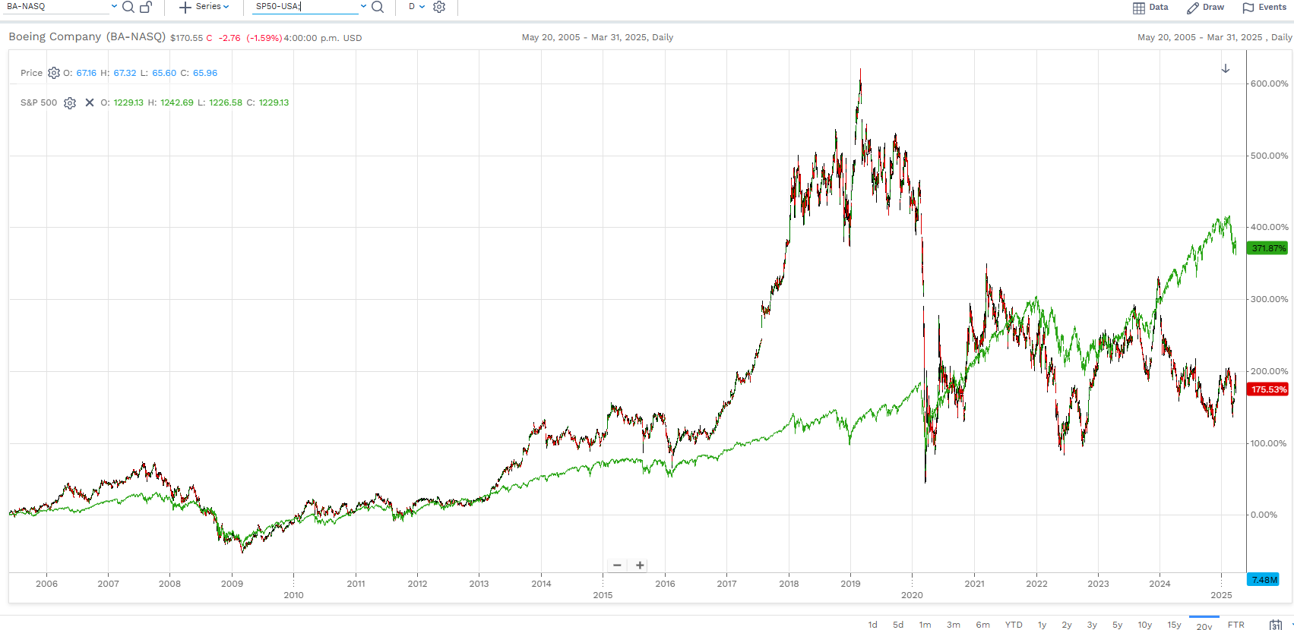

Trade Deficits and Trade Surpluses
We have heard since Donald Trump’s first term about the trade deficit in manufacturing that the United States has with many nations. According to the United States Trade Representative, in 2024, the United States had a $63.3 billion dollar trade deficit in goods with Canada (meaning the United States purchased more goods from Canada than what Canada purchased from the United States). One of the largest reasons why the United States has a trade deficit is due to the price of crude oil which is Canada’s largest export to the United States. When the price of crude oil rallies, the Canada-US trade balance narrows and when the price of crude oil falls, the trade balance widens. In fact, if crude oil was removed from the US – Canada trade statistics, Canada would purchase more goods from America than what America purchases from Canada.
However, beyond trade in goods, there is also trade in services between the United States and Canada. There are many examples of this – tourism, business services (i.e. advertising, legal or accounting, engineering services, computer and telecommunication (call center) services, construction, education services, financial services, etc.).
In this area of service trade, Canada buys substantially more from the United States than what the United States buys from Canada. Think of all of the services you use potentially daily (from Google, Facebook, Microsoft, film studios, publishers, etc) that are from the United States. In fact, as of 2022, Canada runs a $24.1 billion dollar trade deficit with the United States in terms of services (we purchase more in services than what the United States purchases from Canada). The targeting of U.S commercial services could be quite attractive and an area that governments (and individuals with their vacation plans) can have a substantial impact on.
Finally, if you have any questions or concerns, please let me know. This has been an interesting start to the year and if you have any issues, please let me know.
Don
If you are currently a client of BMO Nesbitt Burns, please indicate the name of your Investment Advisor.
This third party publication is not prepared or approved by BMO Nesbitt Burns Inc. and BMO Nesbitt Burns Ltee/Ltd. (“BMO Nesbitt Burns”) and therefore does not meet Canadian research disclosure requirements applicable to BMO Nesbitt Burns. The opinions, estimates and projections contained in the publication are those of the author as of the date indicated and are subject to change without notice. BMO Nesbitt Burns makes no representation or warranty, express or implied, in respect thereof, takes no responsibility for any errors or omissions which July be contained therein and accepts no liability whatsoever for any loss arising from any use of or reliance on the report or its contents. The provision of this publication is not to be construed as an offer to sell or a solicitation for or an offer to buy any securities. BMO Nesbitt Burns or its affiliates July buy from or sell to customers the securities of issuers mentioned in this publication on a principal basis. BMO Nesbitt Burns, its affiliates and/or their respective officers, directors or employees July from time to time acquire, hold or sell securities of issuers mentioned in the publication, related securities, or options, futures or other derivative instruments based thereon. BMO Nesbitt Burns July act as financial advisor and/or underwriter for certain of the issuers mentioned therein and July receive remuneration for same. BMO Nesbitt Burns is a wholly owned subsidiary of BMO Nesbitt Burns Corporation Limited, which is an indirect wholly-owned subsidiary of Bank of Montreal. Bank of Montreal or its affiliates July have lending arrangements with, or provide other remunerated services to, the issuers mentioned herein. The reader should assume that BMO Nesbitt Burns or its affiliates July have a conflict of interest and should not rely solely on this publication in evaluating whether or not to buy or sell securities of issuers discussed herein.

What are tariffs | BDC.ca
List of countries by tariff rate - Wikipedia
Trump's tariffs drive US physical market aluminium premiums to record high | Reuters
Claims of Shoddy Production Draw Scrutiny to a Second Boeing Jet - The New York Times
Airlines Complain About Boeing 787 Dreamliner Quality, Production - Business Insider
Production Problems Spur Broad FAA Review of Boeing Dreamliner Lapses - WSJ
Boeing to resume 787 deliveries no sooner than February | News | Flight Global
Boeing cuts 787 production after structural fault found
Union Busting Doesn't Pay Off for Boeing - Economic Opportunity Institute Economic Opportunity Institute
CER – Canadian Crude Oil Exports: A 30 Year Review
Blame Oil For Our Trade Deficit With Canada
Services Brochure – World Trade Organization - 2015
The U.S. actually has a huge trade surplus in services – that’s where Canada should hit – the Globe and Mail – March 12, 2025

