The Government Change of Reporting for Bare Trusts

As announced on March 28th, 2024 (right before Easter), the government will not require bare trusts to file a T3 Income Tax and Information Return (T3 return), including Schedule 15 (Beneficial Ownership Information of a Trust), for the 2023 tax year, unless the CRA makes a direct request for these filings.

As a reminder, a formal definition of a bare trust is “A bare trust for income tax purposes is a trust arrangement under which the trustee can reasonably be considered to act as agent for all the beneficiaries under the trust with respect to all dealings with all of the trust’s property.”

Some common examples of bare trusts are:
- a parent co-signing a mortgage for their child and going on the title.
- a parent or grandparent who has an account for a minor child or grandchild.
- an adult child with joint ownership of their parent’s bank account, investments or real estate for estate planning purposes.
Note: Certain trusts with assets under $50,000 may not be required to file.

Please note this requirement has only been waived for this year and could be reinstituted for next year.

Executor Services

I have had 5 clients ask about executor services in the last 3 months. When 5 individual clients ask about 1 topic, I need to let everyone know that we do offer a service where BMO Trust can act as your executor or power of attorney either alone or with a family member. This can make things easier when an estate situation comes up. If you would like to discuss this service, please let me know.

Notice of Assessment
It would be valuable for you to drop off or send to me your notice of assessment when your taxes are filled. One of the most important items on this document sent to you by the Canada Revenue Agency is unused capital losses from previous years which can help me with tax planning for your accounts.

If you have any questions or concerns, please let me know!

Don

______________________________________________________________________
Don McGugan, MBA, CFP
Portfolio Manager
Senior Wealth Advisor
Senior Investment Advisor
Financial Planner
BMO Nesbitt Burns
www.donmcgugan.com

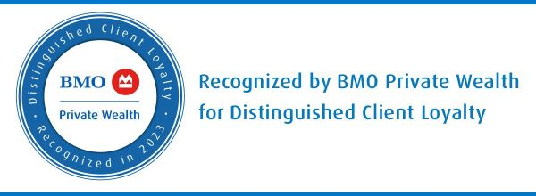

Investment Team
Prelipceanu, Helene
Investment Representative
Assistant to Don McGugan
BMO Nesbitt Burns
Phone (519) 258-2448

Office Locations
Chatham Office
819 St Clair Street
Chatham, Ontario N7M 5J7
Phone (519) 354-7060
Toll-free (866) 575-0255

Wallaceburg Office
770 James Street
Wallaceburg, Ontario N8A 2P5
Phone (519) 627-8782
Toll-free (800) 354-9127

Sarnia Office
429 Exmouth St, Suite 203,
Sarnia, Ontario N7T 5P1
Phone (519)344-8181
Toll-free (888) 229-9901

Mailing Address
100 Ouellette Avenue, Suite 1100
Windsor, Ontario
N9A 6T3

At BMO Nesbitt Burns, we care about the safety of our clients and professionals. To help keep you and our team healthy, and to support public health efforts to manage the spread of COVID-19, we are striving to eliminate traffic to our offices. We are still open for business, and happy to connect by email, phone or using one of our virtual meeting options. Thank you for your understanding. Your safety will always be our priority.

Please note: We cannot take trading instructions via email or voice mail, please contact your Investment Advisor directly.
For disclaimer details, please click here: http://www.bmo.com/nesbittburns/popups/about-us/disclaimers.

Veuillez prendre note que nous ne pouvons accepter des instructions de négociation par courriel, par téléphone ou par messagerie vocale. Veuillez communiquer directement avec votre conseiller en placement.
Pour plus de détails sur l’avis de non-responsabilité, cliquez ici : http://www.bmo.com/nesbittburns/popups/about-us/disclaimers.

https://www.canada.ca/en/revenue-agency/services/tax/trust-administrators/t3-return/new-trust-reporting-requirements-t3-filed-tax-years-ending-december-2023.html

